CHAPTER 1

INTRODUCTION

DESCRIPTION

Monitoring plant health and providing proper care are essential for healthy plant growth and long-term plant survival. Children, students, and beginner gardeners often find it difficult to understand the specific requirements of different plant species, including watering schedules, sunlight exposure, and growth conditions. Traditional plant care methods rely heavily on personal experience and fixed reminders, making it difficult to identify plant stress at an early stage and provide appropriate treatment.
Another major challenge is the lack of immediate guidance and an engaging approach to plant care. Symptoms such as yellowing leaves, wilting, and leaf spots may indicate different plant health problems, which beginners may struggle to identify correctly. Additionally, many existing applications depend on continuous internet connectivity and lack features such as offline assistance, growth tracking, and interactive learning, reducing their usefulness in outdoor and educational environments.
With advancements in Artificial Intelligence (AI) and multimodal vision models, plant images can be analyzed to identify species, recognize visible signs of stress, and provide suitable care recommendations. However, many existing applications focus mainly on plant identification or disease detection without integrating comprehensive care management, health score calculation, growth visualization, and gamified learning. Therefore, BloomVerse is proposed as an intelligent, user-friendly, and offline-first plant care application that combines AI-assisted plant analysis, health monitoring, personalized care guidance, and interactive achievements to encourage responsible gardening and environmental awareness. It also motivates users to maintain consistent plant care habits by transforming gardening into an enjoyable, interactive, and rewarding experience.

1.2 PROBLEM STATEMENT
Monitoring plant health and providing proper care are essential for maintaining healthy plant growth and survival. Children, students, and beginner gardeners often struggle to understand the specific requirements of different plant species, including watering schedules, sunlight exposure, and suitable growing conditions. Traditional plant care methods mainly depend on manual observation and fixed reminders, which may not accurately address the changing needs of individual plants.
One of the major challenges is the difficulty in identifying plant health problems at an early stage. Symptoms such as yellowing leaves, wilting, and leaf spots may indicate different underlying issues. Without sufficient botanical knowledge, users may misinterpret these symptoms and provide inappropriate care, potentially affecting plant growth and survival.
Furthermore, many existing plant care applications focus primarily on plant identification or disease detection and may lack integrated features such as daily care tracking, growth monitoring, personalized recommendations, and interactive learning. Some applications also depend on continuous internet connectivity, limiting their usefulness in outdoor gardens and areas with poor network access. The absence of engaging activities and achievement-based motivation can also reduce users' interest in maintaining plants consistently.
Therefore, an intelligent and user-friendly plant care solution is required to simplify gardening and improve plant health management. The proposed BloomVerse application addresses these challenges by integrating AI-assisted plant analysis, a mathematical health evaluation engine, offline diagnostic support, personalized care recommendations, and interactive growth tracking. It aims to encourage consistent gardening habits, improve plant care awareness, and promote environmental responsibility through an engaging digital experience.

1.3 PLANT CARE APPLICATION DOMAIN
Plant care and monitoring involve understanding plant species, tracking growth, maintaining suitable environmental conditions, and providing appropriate care to ensure healthy plant development. With the advancement of digital technologies, plant care applications are becoming useful tools for helping users monitor plant health, manage daily gardening activities, and improve their knowledge of plant requirements.

1.3.1 Plant Data Management
Plant data management involves storing and maintaining information related to plant species, planting dates, watering schedules, sunlight exposure, growth stages, and daily care activities. This information is essential for monitoring plant development and providing suitable care guidance based on individual plant requirements.This approach supports organized plant management.

1.3.2 AI-Based Plant Analysis System
AI-based plant analysis involves examining plant images to identify plant species and recognize visible symptoms that may indicate health problems. Traditional plant monitoring depends mainly on manual observation and botanical knowledge, which can make it difficult for beginners to recognize plant stress accurately. BloomVerse incorporates Google Gemini Vision to analyze uploaded plant images and provide AI-assisted observations.

1.3.3 Interactive Plant Growth
Interactive plant growth and gamification combine digital visualization, progress tracking, and achievement-based activities to make plant care more engaging. These features are particularly useful for children and beginner gardeners because they provide visible progress and encourage consistent participation in gardening activities. BloomVerse includes a virtual garden, an animated plant companion, daily care missions, and plant lifecycle progression.

1.4 AIM AND OBJECTIVES

1.4.1 Aim
The aim of this project is to develop an AI-powered, offline-first plant care application using Flutter and Dart that assists users in monitoring plant health, analyzing plant images, tracking growth stages, and receiving suitable care recommendations. The project also aims to combine AI-assisted plant analysis, local data management, and gamification to make plant care more accessible, educational, and engaging for children and beginner gardeners.

1.4.2 Objectives
- To develop a cross-platform plant care application using Flutter and Dart.
- To implement AI-assisted plant image analysis using Google Gemini Vision.
- To maintain plant profiles and daily care histories using local data storage.
- To implement watering reminders and plant growth-stage tracking.
- To provide an interactive virtual garden and gamified plant care activities.

1.5 SCOPE OF THE PROJECT
The scope of this project focuses on developing an AI-assisted, offline-first plant care application that simplifies plant maintenance and makes gardening an engaging educational activity. The application enables users to create profiles, add plants, record daily care activities, analyze plant images, and receive appropriate care recommendations. Its SHARP health evaluation engine calculates plant vitality scores, while the AI analysis module provides image-based observations when cloud connectivity is available. The proposed application can be used in:
- Home Gardening: Managing houseplants and maintaining regular care schedules.
- Educational Institutions: Teaching children and students about plant growth and environmental responsibility.
- Environmental Awareness Programs: Encouraging sustainable gardening practices and nature-based learning.

CHAPTER 2

LITERATURE SURVEY

2.1 USING DEEP LEARNING FOR IMAGE-BASED PLANT DISEASE DETECTION, S. P. MOHANTY, D. P. HUGHES, M. SALATHÉ – (2016)
This study focuses on using deep learning techniques to identify plant diseases from leaf images. The researchers developed a convolutional neural network (CNN) model using the PlantVillage dataset, which contains 54,306 images of healthy and diseased plant leaves. The study demonstrates how automated image classification can support plant disease identification and reduce dependence on manual inspection.
The CNN architecture consists of convolutional layers, pooling layers, and fully connected layers. Convolutional layers extract important visual features, such as leaf color, spots, and texture variations, while pooling layers reduce feature dimensions. The final classification layers use these extracted features to distinguish between healthy and diseased plant categories.
The researchers reported a classification accuracy of 99.35% on the test dataset under controlled conditions. This result demonstrated the potential of deep learning for recognizing plant diseases from images. However, the performance was lower when the model was evaluated using images collected from different real-world environments, highlighting the importance of diverse training data.
This study provides a foundation for developing AI-assisted plant analysis systems. It is relevant to BloomVerse because the application uses Google Gemini Vision to analyze plant images and provide observations about potential health problems. Unlike the CNN-based model in this study, BloomVerse combines cloud-based image analysis with a rule-based offline diagnostic mechanism to support everyday plant care. The findings of this study demonstrate the potential of AI-based image analysis for identifying plant health problems. BloomVerse applies this concept using Google Gemini Vision to analyze plant images.

2.2 IRRIGATION SCHEDULING APPROACHES AND APPLICATIONS: A REVIEW, Z. GU ET AL. – (2020)
This study reviews irrigation scheduling methods used to determine the appropriate timing and quantity of water required by plants. The researchers examine approaches based on evapotranspiration, water balance, soil moisture, plant water status, and mathematical models. The study emphasizes that appropriate watering practices are important for maintaining plant growth and avoiding unnecessary water consumption.
The reviewed approaches use environmental observations, soil conditions, and plant water requirements to estimate when irrigation should occur. Soil moisture measurements can indicate the amount of water available to plants, while evapotranspiration methods estimate water loss from soil and vegetation. Model-based methods can combine different parameters to support watering decisions.
The research explains that each scheduling method has advantages and limitations depending on the availability of data, measurement equipment, environmental conditions, and plant requirements. Fixed watering schedules may not always reflect actual water needs, whereas sensor-based and model-based approaches can provide more context-sensitive decisions.
This research supports the watering reminder and plant care scheduling features of BloomVerse. The application maintains watering intervals and records daily care activities to remind users when watering is due. Unlike advanced irrigation systems, BloomVerse does not use soil moisture sensors or directly control irrigation equipment; it provides software-based reminders and health assessments to help users maintain consistent care routines. The application maintains watering intervals and records daily care activities to remind users when watering is due. Unlike advanced irrigation systems, BloomVerse does not use soil moisture sensors or directly control irrigation equipment; it provides software-based reminders and health assessments to help users maintain consistent care routines.

2.3 A SYSTEM FOR AUTOMATIC RICE DISEASE DETECTION FROM RICE PADDY IMAGES SERVICED VIA A CHATBOT, P. TEMNIRANRAT ET AL. – (2021)
This research presents an automated rice disease detection system that combines image analysis with a chatbot interface. The system was designed to help users identify rice diseases from photographs captured in actual paddy field environments. It addresses the need for accessible diagnostic assistance when agricultural experts may not be immediately available.
The proposed approach processes rice plant images using computer vision and machine learning techniques. A chatbot based on the LINE messaging platform provides the user interface through which users can submit images and receive diagnostic results. The system also incorporates image data refinement to improve disease detection performance.
The study demonstrates how combining automated image analysis with conversational interaction can make technical diagnostic systems easier to access. However, the usefulness of the system depends on the quality of the submitted images, the diseases supported by the model, and the reliability of the classification results. A chatbot interface also needs to communicate results clearly so users can understand the next steps.
This research is directly relevant to BloomVerse's AI analysis and AI Eco Buddy Chat modules. BloomVerse allows users to analyze plant images and ask plant-related questions through a conversational interface. It extends the concept by combining AI-assisted observations with watering reminders, plant profiles, and daily care tracking.
The findings of this study support the development of AI-assisted plant analysis systems that provide accessible diagnostic guidance. BloomVerse extends this concept by integrating Gemini Vision with personalized care recommendations, plant health monitoring, and daily care tracking.

2.4 SMART IRRIGATION MONITORING AND CONTROL STRATEGIES FOR IMPROVING WATER USE EFFICIENCY IN PRECISION AGRICULTURE: A REVIEW – (2021)
This research reviews smart irrigation monitoring and control strategies developed to improve water-use efficiency in agriculture. It examines the use of soil-based, plant-based, and weather-based information to determine when and how much water should be supplied. The study highlights the importance of matching irrigation schedules to changing environmental and plant conditions.
The reviewed systems use monitoring devices, communication technologies, and control algorithms to support watering decisions. Some approaches follow predefined schedules, while others adjust irrigation based on sensor measurements and feedback. Closed-loop strategies can respond to changing conditions instead of relying entirely on fixed schedules.
The review explains that combining environmental measurements with predictive models can improve irrigation decisions and reduce unnecessary water use. However, these systems may require sensors, communication infrastructure, calibration, and additional installation costs. Their effectiveness also depends on the accuracy of measurements and the ability of control algorithms to respond appropriately.
The study provides background for BloomVerse's watering reminder and hydration assessment features. BloomVerse records watering activities and evaluates hydration as one of the factors in its SHARP plant health engine. Although it does not provide sensor-controlled irrigation, it helps users track watering routines and identify when a plant may require attention.
This study highlights the importance of reliable image analysis and intelligent plant health assessment. BloomVerse incorporates these concepts through its AI-assisted analysis and SHARP health evaluation engine. The combination helps users monitor plant conditions and understand their plant care requirements.

2.5 EVALUATING PLANT DISEASE DETECTION MOBILE APPLICATIONS: QUALITY AND LIMITATIONS, A. SCIARRETTA ET AL. – (2022)
This study evaluates mobile applications designed for plant disease detection, diagnosis, and treatment assistance. The researchers reviewed applications available through major mobile application stores and assessed their functionality and software quality. The study focuses on whether existing applications provide reliable plant identification, disease detection, severity assessment, and treatment recommendations.
The evaluation considered several aspects of mobile application design, including usability, performance, visual presentation, and AI-based functionality. The researchers identified applications with different levels of diagnostic capability and examined the availability of plant databases and treatment information. The study provides an assessment framework for understanding the practical usefulness of plant health applications.
The findings indicated that many evaluated applications lacked important advanced diagnostic features or did not provide a complete solution for plant disease identification and treatment. The authors highlighted the need for improvements in AI functionality, user experience, and evidence-based recommendations. These findings demonstrate that an application should support users beyond simply displaying a classification result.
BloomVerse addresses this broader requirement by combining AI-assisted image analysis with plant health scores, daily check-ins, care recommendations, watering reminders, and plant growth tracking. Its interactive garden and certificate features also support user engagement. The research is useful for guiding the design of an integrated plant care application rather than an image classifier alone. The research emphasizes the need for accessible plant disease detection and practical care guidance. BloomVerse addresses this need by combining AI-assisted plant analysis with watering reminders, health score calculation, and care recommendations. These features support a more comprehensive plant care experience.

2.6 IDENTIFYING TOMATO LEAF DISEASES UNDER REAL FIELD CONDITIONS USING CONVOLUTIONAL NEURAL NETWORKS AND A CHATBOT, H.-H. CHENG ET AL. – (2022)
This research investigates tomato leaf disease identification under real field conditions using deep learning and a chatbot interface. The study addresses the difficulty of identifying diseases from photographs taken outside controlled laboratory environments. Real-world images may contain shadows, background objects, overlapping leaves, and variations in lighting that affect disease classification.
The researchers collected nearly 9,000 images of diseased tomato leaves under field conditions. Their approach included an anomaly detection model to check whether an input image was suitable for analysis and a YOLOv4 model to identify tomato disease categories. The models were hosted through a cloud service, and a LINE chatbot was developed to make the system accessible to users.
The study demonstrates the value of combining image validation, object detection, cloud-based processing, and conversational access. However, the system is designed around tomato diseases, so its diagnostic coverage cannot automatically be extended to all plant species. Image quality and the range of supported disease categories remain important considerations.
This research is relevant to BloomVerse's Gemini Vision analysis and AI Eco Buddy Chat modules. BloomVerse uses cloud-based AI to analyze plant photographs and provide general care guidance, while the conversational assistant helps users ask questions about plant maintenance. Its broader plant care approach also incorporates watering reminders, plant health evaluation, and lifecycle tracking.
This research demonstrates the usefulness of combining AI-based plant analysis with conversational interfaces. BloomVerse follows a similar approach through its AI Eco Buddy Chat and Gemini Vision-based analysis. It further supports users with offline guidance, plant growth tracking, and interactive gardening activities. Its broader plant care approach also incorporates watering reminders, and tracking.

2.7 A SURVEY ON INTELLIGENT AGENTS AND MULTI-AGENTS FOR IRRIGATION SCHEDULING, A.-F. JIMENEZ ET AL. – (2020)
This study reviews the use of intelligent agents and multi-agent systems for irrigation scheduling. Intelligent agents are software entities that use available information to select actions according to defined objectives. In irrigation applications, these agents can consider soil conditions, plant requirements, and environmental information to support watering decisions.
The researchers discuss intelligent systems that use perception, reasoning, planning, learning, and communication to manage irrigation activities. Multi-agent approaches allow different software components to coordinate information and contribute to scheduling decisions. Such approaches can help manage the changing requirements of plants across different locations and periods.
The review identifies opportunities for improving irrigation management through intelligent decision-making and coordination. However, the performance of these systems depends on the quality of input data, the reliability of environmental measurements, and the suitability of the decision-making rules. Implementing advanced intelligent irrigation may also require additional infrastructure.
The research provides a conceptual foundation for BloomVerse's rule-based plant health evaluation and watering management. BloomVerse combines watering records, sunlight information, care consistency, and lifecycle progression to calculate a plant vitality score. Although its SHARP engine is a local deterministic evaluation model rather than a multi-agent irrigation controller, it applies the broader principle of using structured information to support plant care decisions.
The study highlights the importance of using structured information to support plant care decisions. BloomVerse applies this principle through its SHARP health evaluation engine, which considers hydration, sunlight, consistency, and growth progression. Watering reminders and daily check-ins further encourage consistent plant maintenance.

2.8 LITTLE BOTANY: A MOBILE GAME UTILIZING DATA INTEGRATION TO ENHANCE PLANT SCIENCE EDUCATION, JAMONNAK ET AL. – (2017)
This research introduces Little Botany, a mobile educational game designed to help school-aged children learn about plants through virtual gardening. The application allows users to create gardens, select crops, maintain plants, and observe their growth. It combines digital interaction with plant science concepts to encourage children to explore the natural environment.
The system integrates real-world information, including location and weather data, to simulate how environmental conditions influence plant growth. Users participate in gardening activities and observe changes as they care for their virtual plants. This approach makes plant science more interactive than conventional learning methods that rely primarily on textual explanations.
The study demonstrates how mobile games can provide an engaging environment for learning about plant development and gardening activities. However, the educational effectiveness of such systems depends on the quality of the learning activities and how well the virtual experience communicates real plant care principles. Virtual growth should also be distinguished from the actual biological condition of a physical plant.
This research is highly relevant to BloomVerse's virtual garden, plant companion, daily care missions, and achievement certificate features. BloomVerse uses interactive visual elements and lifecycle milestones to encourage users to care for real plants consistently. By combining gamification with plant health monitoring and AI-assisted guidance, the application aims to make gardening both educational and rewarding.
The findings demonstrate how virtual gardening and interactive activities can encourage interest in plant science. BloomVerse incorporates these principles through its virtual garden, animated plant companion, and daily care missions. These features make gardening more engaging while encouraging users to care for real plants.

2.9 DEVELOPMENT OF A GAMIFICATION-BASED MOBILE APPLICATION FOR OUTDOOR PLANT OBSERVATION AND ENVIRONMENTAL EDUCATION, J. HAN AND S.-J. YUN – (2024)
This study investigates the development of a gamification-based mobile application intended to encourage outdoor plant observation and improve environmental education. The research focuses on helping students observe plants independently and develop a stronger interest in nature through structured digital activities. It explores how mobile technology can support learning beyond the classroom.
The researchers developed the application using educational objectives, plant observation activities, gamification principles, and self-efficacy concepts. The system was introduced into a school learning environment, where students used the application to participate in plant observation activities. Questionnaires were used to evaluate changes in students' interest in plants and confidence in observing them.
The study reported statistically significant improvements in plant-observation self-efficacy and interest among the participating students. These findings suggest that well-designed mobile learning experiences can encourage engagement with nature. However, the results relate to the study's specific educational context and should not be assumed to apply identically to every user group or application.
This research supports BloomVerse's focus on children, students, and beginner gardeners. Features such as daily missions, an animated plant companion, virtual garden visualization, and milestone certificates are intended to motivate continued participation in gardening. The study provides a useful basis for incorporating educational and gamified elements alongside plant care functionality.
This research supports the use of gamification to improve engagement in plant-related learning activities. BloomVerse applies this concept through lifecycle certificates, and interactive garden visualization. These features encourage users to maintain regular care routines and develop environmental awareness.

2.10 PLANT CARE AI: AN AI-BASED SOLUTION FOR PLANT DISEASE DIAGNOSIS AND ASSISTANCE—A COMPREHENSIVE SURVEY, A. KULKARNI ET AL. – (2024)
This research surveys AI-based plant care approaches that combine image recognition, plant disease diagnosis, treatment recommendations, and chatbot assistance. It addresses the need for integrated systems that help users identify plant health concerns and understand appropriate next steps. The study discusses the potential of artificial intelligence to make plant care guidance more accessible to users with limited botanical knowledge.
The proposed system concept combines image-based disease identification with an interactive interface for plant-related questions. A conversational assistant can explain diagnostic results and provide care suggestions in a form that is easier for users to understand. Integrating these functions into one application can reduce the need to consult multiple separate tools for plant identification, diagnosis, and guidance.
The research highlights the potential benefits of combining AI-assisted diagnosis with treatment recommendations and conversational interaction. However, the reliability of the overall system depends on the underlying image analysis, the quality of the information used to generate recommendations, and the clarity of the chatbot's responses. AI-generated suggestions also need to be interpreted carefully when the plant condition is uncertain.
This research closely matches the integrated approach adopted by BloomVerse. The application combines Gemini Vision-based plant analysis, an watering reminders, SHARP health scoring, local plant records, and limited offline diagnostic guidance. It also incorporates growth tracking and gamification to encourage consistent care. Together, these modules aim to provide a comprehensive and accessible plant care. The study supports integrating AI-assisted diagnosis with conversational guidance in plant care applications. BloomVerse extends this approach through Gemini Vision, and the SHARP health evaluation engine.

CHAPTER 3

EXISTING SYSTEM

3.1 EXISTING SYSTEM
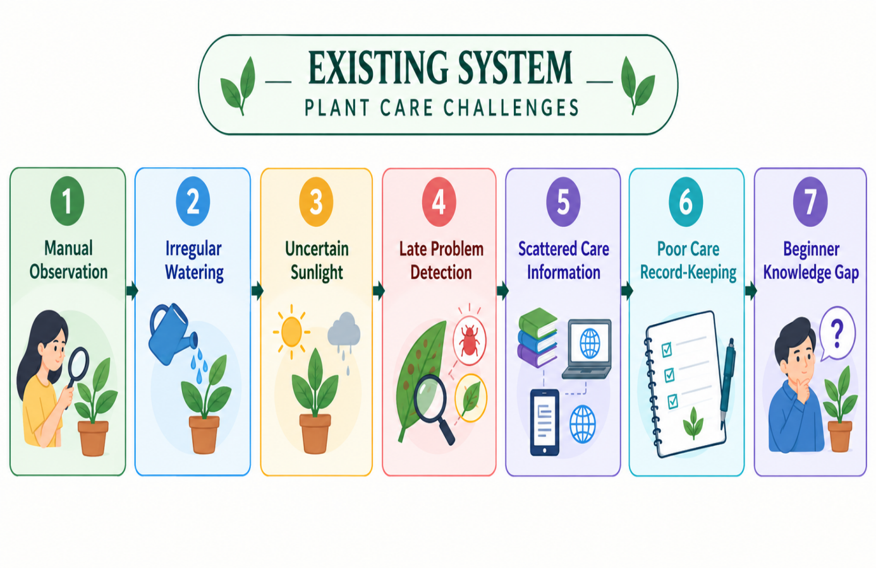
Existing plant care systems mainly rely on manual observation, personal experience, and fixed watering reminders, making maintenance difficult for beginners. Users may struggle to identify plant diseases and understand specific watering and sunlight requirements. Although digital applications provide plant identification and disease detection, their features are often scattered across multiple tools. Many systems lack integrated health scoring, daily care records, lifecycle monitoring, and growth tracking. Limited offline accessibility, interactive learning, and achievement-based rewards may also reduce user engagement. Therefore, an integrated plant care system is needed to monitor plant health, provide personalized care guidance, and encourage consistent gardening habits.
Figure 3.1 Existing System

3.2 DISADVANTAGES
- Requires expert knowledge, which may not be easily available to all farmers.
- Requires regular manual observation and effort to maintain plant health.
- Time-consuming process for identifying plant species, diseases, and pests.
- Difficulty in detecting early-stage diseases due to subtle or unclear symptoms.
- Similar-looking leaf condition can cause misclassification and wrong treatment.

CHAPTER 4

PROBLEMS IDENTIFIED
Traditional plant care methods require users to manually observe plants and maintain regular watering and sunlight schedules. Children, students, and beginner gardeners may find it difficult to understand the specific requirements of different plant species. The lack of proper guidance and consistent monitoring can lead to improper care, delayed identification of plant stress, and reduced plant survival.
Although several plant care applications are available, many focus primarily on plant identification, disease detection, or basic watering reminders. These applications may not provide an integrated solution for monitoring plant health, tracking growth stages, recording daily care activities, and offering personalized recommendations. Furthermore, fixed reminders may not adequately reflect the different care requirements of individual plants.
Another major challenge is the limited availability of plant care assistance when internet connectivity is unavailable. AI-based analysis and online services may require an active network connection, making them less accessible in outdoor gardens, educational institutions, and areas with poor connectivity. In addition, the absence of interactive learning activities and engaging visual features can reduce the interest of children and beginner gardeners in maintaining plants consistently.
Traditional plant care practices can also result in incorrect decisions when users misinterpret symptoms such as yellowing leaves, wilting, or leaf spots. Without suitable guidance, users may apply inappropriate care methods that negatively affect plant development. Therefore, there is a need for an intelligent, user-friendly, and offline-first plant care application that combines AI-assisted plant analysis, health score calculation, watering reminders, personalized care guidance, and growth monitoring.

CHAPTER 5

PROPOSED SYSTEM

5.1 PROPOSED SYSTEM OVERVIEW
The proposed system aims to develop an intelligent plant analysis platform that identifies plant species and detects. The proposed system aims to develop BloomVerse, an intelligent and interactive plant care application that helps users monitor plant health, manage daily care activities, and understand plant growth requirements. Traditional plant care methods depend on manual observation and fixed reminders, which may not adequately address the individual requirements of different plant species. BloomVerse introduces a digital approach that combines Artificial Intelligence (AI), local data management, and gamification.

5.2 AI BASED PLANT ANALYSIS
The proposed system incorporates Google Gemini Vision to analyze plant images and provide AI-assisted information about plant species and visible health conditions. Users can capture a plant photograph using the camera or select an existing image for analysis. The image is processed by the AIService module, which communicates with the configured Gemini model when network connectivity is available. During analysis, the AI service examines the submitted image and generates observations about visible plant characteristics, potential health problems, and suitable care recommendations.

5.3 PLANT HEALTH EVALUATION AND WATERING REMINDERS
Plant health evaluation is an important component of BloomVerse, designed to help users understand the overall condition of their plants. The application implements the SHARP multi-factor health evaluation engine, which considers hydration, sunlight exposure, care consistency, and growth progression.
The WateringService manages daily care check-ins and updates watering records. Based on the plant's configured watering interval and the previous watering date, the application determines the next expected watering date and supports reminders through the NotificationService. Users can also record sunlight exposure and daily care activities, helping the system maintain a history of plant maintenance and encourage consistent gardening routines.

5.4 AI ECO BUDDY CHAT AND PERSONALIZED CARE GUIDANCE
The AI Eco Buddy Chat module provides a conversational interface through which users can ask questions related to plant care and gardening. It is designed to help children, students, and beginner gardeners understand plant requirements without needing advanced botanical knowledge. Users can seek guidance about watering, sunlight, common plant problems, and general plant maintenance. The conversational assistant uses the configured AI service to generate responses to plant-related questions. By presenting information in a simple and accessible manner, it helps users understand recommended care practices and respond more effectively.

5.5 PLANT GROWTH TRACKING AND GAMIFICATION
Plant growth tracking and gamification are key components of BloomVerse that make plant care engaging and educational. The application estimates lifecycle progression using the planting date and the configured lifespan of the selected plant. Based on this calculation, the plant progresses through four stages: seed, sprout, growing plant, and fully grown plant.

5.6 RESULT VISUALIZATION AND LOCAL DATA MANAGEMENT
After plant analysis and health evaluation, BloomVerse displays the available results through a user-friendly interface. Users can view plant details, health scores, status indicators, warnings, care recommendations, watering schedules, and lifecycle progress. Plant cards and detail screens provide convenient access to important information, helping users understand their plants' care requirements.
The application maintains plant profiles and daily care histories through local data storage. SharedPreferences and JSON serialization support the storage and retrieval of application records, while sandboxed file storage supports relevant local media and generated certificates. This arrangement enables users to review available records and continue core plant management activities without requiring continuous internet access.

5.7 PROPOSED SYSTEM ARCHITECTURE
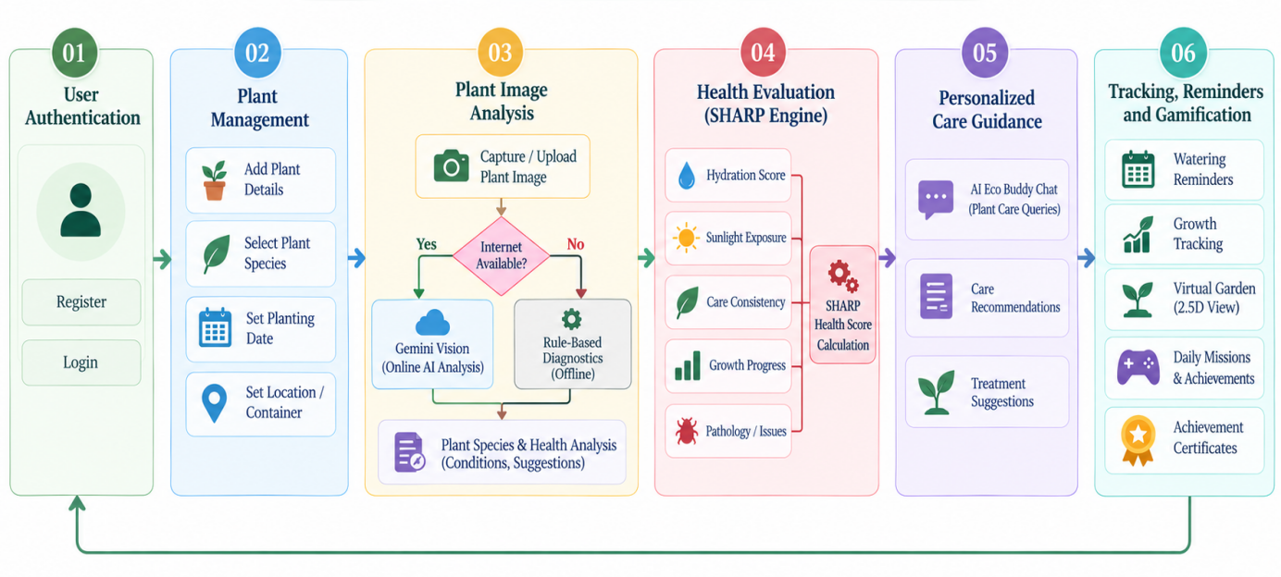
Figure 5.7 Proposed System

5.8 ADVANTAGES
- Provides AI-assisted plant image analysis using Google Gemini Vision.
- Calculates plant health scores using the SHARP multi-factor.
- Provides plant care guidance through the AI Eco Buddy.
- Maintains plant profiles and care histories using local data storage.
- Tracks plant lifecycle stages and displays growth progress.
- Improves user engagement through an interactive virtual garden and animated plant companion.

CHAPTER 6

SYSTEM REQUIREMENTS

6.1 HARDWARE REQUIREMENTS

Processor
A computer system with an Intel Core i3/i5 processor or equivalent is required to develop and run the BloomVerse application. A modern multi-core processor is recommended for smooth execution of Flutter development tools, Android emulators, application builds, and testing activities. The processor also handles local plant health calculations and application logic.

Memory (RAM)
A minimum of 4 GB RAM is required, while 8 GB or more is recommended for better performance. Sufficient memory supports the Flutter development environment, Android SDK, emulator execution, and project compilation. Additional memory is beneficial when multiple development tools are used simultaneously.

Storage
A minimum of 10 GB of free storage is recommended for the project, while 20 GB or more is preferable when installing Flutter, Android Studio, SDK components, and emulators. SSD storage is recommended to improve application build times and file access. Additional space may be required for plant images, generated certificates, development dependencies, and testing resources.

Camera / Smartphone
An Android smartphone or compatible device is required to test the mobile application and capture plant images for AI-assisted analysis. A camera with adequate resolution and good lighting conditions helps provide clearer images for analysis. Device testing also verifies watering notifications, local storage, virtual garden interactions, and other mobile features.

Internet Connectivity
An active internet connection is required to access Google Gemini Vision for cloud-based plant image analysis and AI Eco Buddy Chat functionality. Internet connectivity is also useful for downloading dependencies, updating development tools, and retrieving external AI responses. Core plant management and the rule-based diagnostic fallback can provide limited functionality when the device is offline.

6.2 SOFTWARE REQUIREMENTS

• Frontend (Flutter and Dart)
Flutter is used to develop the user interface and interactive components of BloomVerse, while Dart is the primary programming language. Flutter supports reusable widgets, responsive layouts, animations, and cross-platform application development. It is used to implement onboarding, authentication screens, plant profiles, health dashboards, daily check-ins, the virtual garden, AI chat, and certificate.

• AI Integration (Google Gemini Vision)
Google Gemini Vision is integrated through the configured Google Generative AI REST API to support plant image analysis and conversational plant care assistance. The AI service processes submitted plant images and generates observations and care suggestions. API access requires an appropriate API key, internet connectivity, and a supported model configuration.

• Plant Health Evaluation Engine
The SHARP multi-factor health evaluation engine is implemented in Dart as part of the application's local business logic. It calculates a plant health score using hydration, sunlight exposure, care consistency, and growth progression, with pathology-related penalties incorporated where supported. This engine provides a consistent method for estimating plant vitality without requiring cloud computation for the health score itself.

• Local Storage and Data Management
SharedPreferences is used to store application data through JSON serialization, including supported plant records and care information. Local application storage is used for relevant media files and generated certificates. Bundled JSON species data provides plant information, while the ExcelService supports reading compatible botanical data resources where configured.

• Camera and Image Handling
The image_picker package supports capturing plant photographs or selecting images from the device gallery. These images are used as inputs for AI-assisted plant analysis. Appropriate permissions and platform configuration are required to access camera and gallery functionality.

• Certificate Generation and Sharing
Flutter's rendering capabilities, including RepaintBoundary, are used to capture certificate screens as high-resolution PNG images. The path_provider package supports access to suitable application directories, while share_plus enables users to share generated certificates through compatible applications.

• Development Environment
Visual Studio Code or Android Studio can be used to develop and maintain the BloomVerse application. The development environment requires Flutter SDK 3.19.0 or higher, a compatible Dart SDK, and JDK 17 for the specified Android Gradle Plugin 8.x setup.

• Testing Tools
Flutter unit tests, widget tests, and integration tests are used to verify application functionality. Unit tests validate the SHARP health engine, data models, and watering calculations. Widget and integration tests check interface rendering, form validation, plant management, daily check-ins, AI workflow integration, and certificate generation.

CHAPTER 7

SYSTEM IMPLEMENTATIONS

7.1 LIST OF MODULES

The proposed BloomVerse application consists of several functional modules designed to simplify plant care, monitor plant health, and encourage consistent gardening practices. The modular architecture improves maintainability and integrates AI-assisted analysis, reminders, data management, and gamification into a single platform. The following modules are used in the proposed system:
- User Authentication and Profile Management Module
- AI-Based Plant Image Analysis Module
- Plant Health Evaluation and Watering Reminder Module
- AI Eco Buddy Chat Module
- Plant Growth Tracking and Gamification Module
- Plant History and Certificate Generation Module

7.2 MODULE DESCRIPTION

7.2.1 User Authentication and Profile Management Module
This module provides the entry point for users to access the BloomVerse application. It includes splash screens, onboarding screens, login, registration, and profile setup functionalities. The interface is designed using Flutter and Dart to provide a simple and interactive user experience. Users can create accounts, enter their profile information, and configure their gardening profiles.

7.2.2 AI-Based Plant Image Analysis Module
This module provides AI-assisted analysis of plant images using Google Gemini Vision through the configured Google Generative AI REST API. Users can capture plant photographs using the camera or select existing images from the gallery. The selected image is processed by the AIService module when cloud-based analysis.

7.2.3 Plant Health Evaluation and Watering Reminder Module
This module helps users monitor plant care conditions and maintain consistent watering routines. It uses the SHARP multi-factor health evaluation engine to calculate a plant vitality score based on hydration, sunlight exposure, care consistency, and growth progression. The engine applies predefined weights to these factors and incorporates supported pathology-related penalties when calculating the health score.

7.2.4 AI Eco Buddy Chat Module
The AI Eco Buddy Chat module provides a conversational interface for users to ask questions about gardening and plant maintenance. It is designed to help children, students, families, and beginner gardeners understand plant care requirements in a simple and accessible manner. Users can ask questions about watering schedules, sunlight requirements, common plant problems, and general gardening practices.

7.2.5 Plant Growth Tracking and Gamification Module
This module monitors the expected lifecycle progression of registered plants and introduces interactive elements to encourage consistent plant care. The application calculates plant progression using the planting date and the configured lifespan. Based on the calculated progress, plants are classified into four stages: seed, sprout, growing plant, and fully grown plant.

7.2.6 Plant History and Certificate Generation Module
This module supports the review of plant information and available care records over time. The application maintains plant profiles and daily check-in information through its local data management system. Users can revisit saved plant details, review recorded care activities, and monitor the expected lifecycle progression of their plants.The certificate generation functionality recognizes configured plant lifecycle milestones.

CHAPTER 8

SYSTEM TESTING

8.1 UNIT TESTING
Unit testing is the process of testing individual components of an application independently to verify that each module performs its intended function correctly. In BloomVerse, unit testing focuses on components such as PlantRepository, PlantHealthEngine, WateringService, AIService, and certificate generation functionality. The main purpose of unit testing is to identify errors at an early stage and ensure that individual components operate correctly.

8.2 INTEGRATION TESTING
Integration testing is performed after individual modules have been tested to ensure that they communicate and function correctly as a unified application. In BloomVerse, integration testing verifies the interaction between the Flutter user interface, plant data repository, AI service, health evaluation engine, watering service, and local storage components. For example, when a user adds a plant and records daily watering and sunlight activities, the application should save the check-in information.

8.3 SYSTEM TESTING
System testing involves evaluating the complete BloomVerse application to verify that all implemented features work together according to the specified requirements. The testing process covers user registration, login, plant profile creation, AI-assisted plant analysis, health monitoring, and gamification features. The application is tested through complete user journeys, beginning with onboarding and plant registration and continuing through daily check-ins, health evaluation, AI-assisted guidance, and lifecycle milestone completion.

8.4 PERFORMANCE TESTING
Performance testing evaluates the responsiveness, efficiency, and resource usage of the BloomVerse application under different operating conditions. It examines application startup time, screen navigation, local data retrieval, health score calculation, image handling, and certificate generation.
The SHARP health evaluation engine is tested to verify that it calculates plant vitality scores efficiently using the available care information. The AI analysis module is evaluated separately because response time depends on network connectivity, image size, and the configured Gemini service.

8.5 USABILITY TESTING
Usability testing evaluates how easily users can understand and interact with BloomVerse. Since the application is designed for children, students, families, and beginner gardeners, its interface should be intuitive, visually clear, and easy to navigate.
The application uses interactive screens, readable information, and accessible controls to simplify everyday plant care activities. During usability testing, users can perform tasks such as adding plants, recording daily care activities, checking health scores, viewing watering reminders, asking questions through AI Eco Buddy Chat, and exploring the virtual

CHAPTER 9

RESULT AND DISCUSSION
The performance comparison between the existing system and the proposed system demonstrates the effectiveness of BloomVerse in improving plant care, health evaluation, and growth monitoring. The evaluation is based on key factors such as analysis capability, processing time, health assessment, data management, and user engagement. The existing system mainly depends on manual observation, fixed watering schedules, and separate plant care applications, which may lead to inconsistent assessments and difficulties in maintaining plants effectively.
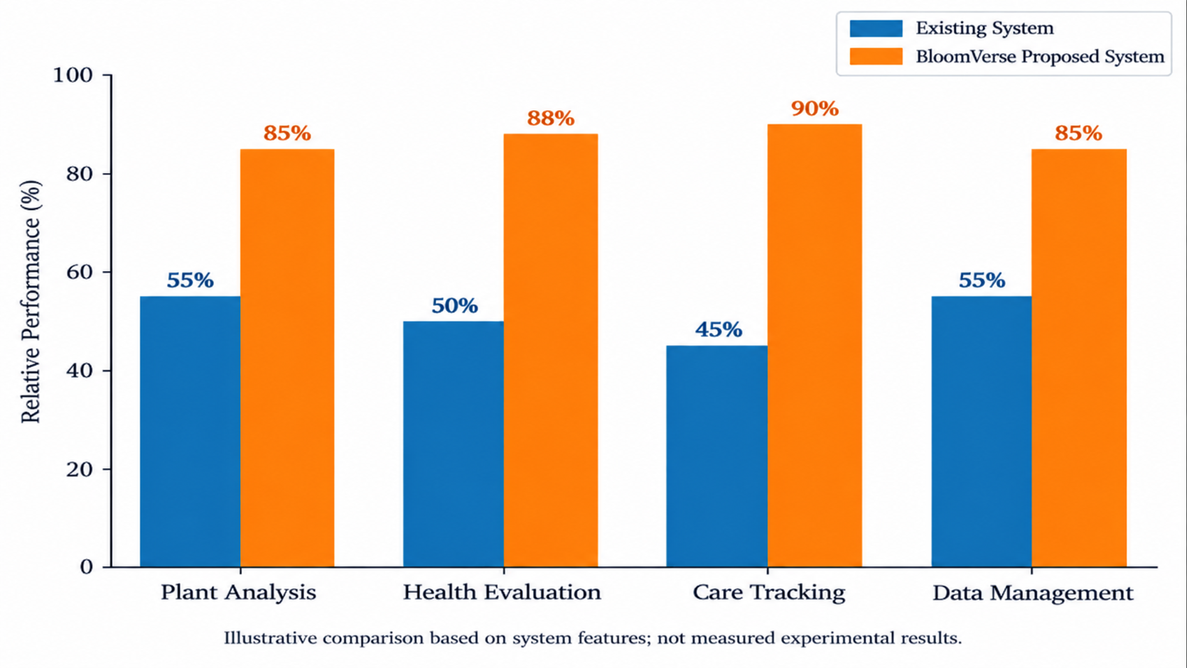
In terms of processing speed and usability, the existing system requires users to identify plant problems manually and refer to different sources for suitable care instructions. BloomVerse simplifies this process by allowing users to submit plant images for AI-assisted analysis and receive relevant guidance. Furthermore, the proposed system enhances plant care management through watering reminders, plant growth tracking, lifecycle monitoring, and persistent local data storage. Therefore, BloomVerse provides a more integrated and interactive approach to plant management than conventional methods.

Figure 9.1 Performance Comparison

CHAPTER 10
CONCLUSION AND FUTURE ENHANCEMENTS
10.1 CONCLUSION
The BloomVerse application was developed to simplify plant care and improve the process of monitoring plant health and growth using modern mobile application technologies and AI-assisted analysis. Traditional plant care methods rely heavily on manual observation, fixed watering schedules, and separate sources of information. These approaches can make it difficult for beginners to identify potential plant health issues, maintain consistent care routines, and track plant development over time.
The proposed BloomVerse application addresses these challenges by integrating Gemini Vision-based plant image analysis with the SHARP plant health evaluation engine. The application includes several modules, such as plant registration, image-based analysis, health evaluation, personalized care recommendations, watering reminders, lifecycle tracking, and local data management.
The implemented features support plant health monitoring, care scheduling, and growth tracking through an interactive and user-friendly interface. The SHARP engine evaluates plant health using factors such as hydration, sunlight, care consistency, and lifecycle progression. Additional features, including the virtual garden, daily missions, achievement certificates, and home screen widgets, encourage users to develop consistent plant care habits.
Overall, BloomVerse demonstrates how AI-assisted image analysis, rule-based evaluation, notifications, and gamification can be combined to create an engaging plant care application. It provides a convenient platform for beginners and plant enthusiasts to manage their plants, receive care guidance, and monitor growth. The project also establishes a foundation.

10.2 FUTURE ENHANCEMENTS
Although the BloomVerse application provides several features for plant care and growth monitoring, additional enhancements can be introduced in the future to improve its capabilities, reliability, and usability.
One possible enhancement is the integration of more comprehensive plant analysis services that can identify a wider range of plant species, diseases, pest-related symptoms, and nutrient deficiencies. The image analysis component could be improved by evaluating its performance using a larger and more diverse collection of plant images captured under different lighting conditions and environments. This would help assess its reliability in practical gardening situations.
Another improvement is the development of more advanced personalized care recommendations. By considering factors such as plant species, local weather conditions, seasonal changes, soil moisture, and environmental temperature, the application could provide more context-aware watering and maintenance suggestions. Integration with suitable IoT sensors could further support automated monitoring of soil moisture, temperature, and light intensity.
The application can also be enhanced by expanding its offline capabilities. A larger local botanical knowledge base and more comprehensive rule-based diagnostic guidance could help users access useful plant care information when internet connectivity is unavailable. Additional language options could make the application more accessible to users from different regions.
Furthermore, future versions could introduce cloud synchronization and secure backup facilities to allow users to access plant records across multiple devices. Community features, expert consultation, plant care sharing, and additional achievement systems could also improve user engagement. Advanced analytics and visual growth timelines could help users observe plant development and understand changes in plant health over time. By implementing these enhancements, BloomVerse can evolve into a more comprehensive and personalized plant care platform.

APPENDIX – A

SOURCE CODE

Sf.html

<!DOCTYPE html>
<html lang="en">
<head>
<meta charset="UTF-8">
<meta name="viewport" content="width=device-width, initial-scale=1.0">
<title>BloomVerse - Interactive Botanical Companion & AI Plant Diagnostics</title>
<meta name="description" content="BloomVerse combines AI leaf pathology diagnostics, smart plant care reminders, 2.5D isometric digital gardening, and native home screen widgets to help you nurture thriving plants.">
<meta name="keywords" content="BloomVerse, plant care app, AI plant diagnostic, plant care companion, indoor gardening, watering reminders, botanical care">
<meta name="author" content="BloomVerse Team">
<meta property="og:type" content="website">
<meta property="og:title" content="BloomVerse - Grow Plants · Grow Future">
<meta property="og:description" content="AI-assisted botanical care companion, leaf diagnostics, and interactive digital gardening.">
<meta property="og:image" content="https://raw.githubusercontent.com/TheOrionGD/BloomVerse/main/assets/icon/app_icon.png">
<link rel="preconnect" href="https://fonts.googleapis.com">
<link rel="preconnect" href="https://fonts.gstatic.com" crossorigin>
<link href="https://fonts.googleapis.com/css2?family=Outfit:wght@300;400;500;600;700;800&family=Plus+Jakarta+Sans:wght@400;500;600;700&display=swap" rel="stylesheet">
<style>
:root {
--bg-dark: #07110c;
--bg-card: rgba(18, 38, 28, 0.7);
--bg-card-hover: rgba(26, 54, 40, 0.85);
--border-color: rgba(74, 222, 128, 0.18);
--border-bright: rgba(74, 222, 128, 0.4);
--primary: #22c55e;
--primary-glow: rgba(34, 197, 94, 0.35);
--emerald-light: #4ade80;
--mint: #86efac;
--gold: #fbbf24;
--accent: #10b981;
--text-main: #f0fdf4;
--text-muted: #94a3b8;
--text-sub: #cbd5e1;
--radius-lg: 24px;
--radius-md: 16px;
--radius-sm: 10px;
--font-heading: 'Outfit', sans-serif;
--shadow-glow: 0 0 35px rgba(34, 197, 94, 0.25);
}
* {
box-sizing: border-box;
margin: 0;
padding: 0;
}
@keyframes pulse-orb {
0% { transform: scale(1) translate(0, 0); }
100% { transform: scale(1.15) translate(30px, 30px); }
}
.container {
max-width: 1200px;
margin: 0 auto;
padding: 0 24px;
}

header {
position: sticky;
top: 0;
z-index: 100;
backdrop-filter: blur(16px);
-webkit-backdrop-filter: blur(16px);
background: rgba(7, 17, 12, 0.8);
border-bottom: 1px solid var(--border-color);
}
.nav-inner {
display: flex;
align-items: center;
justify-content: space-between;
height: 80px;
}
.btn-primary {
background: linear-gradient(135deg, #22c55e, #10b981);
color: #042f1a;
box-shadow: 0 4px 20px rgba(34, 197, 94, 0.35);
font-weight: 700;
}
.btn-primary:hover {
transform: translateY(-2px);
box-shadow: 0 8px 30px rgba(34, 197, 94, 0.5);
background: linear-gradient(135deg, #4ade80, #10b981);
}
.btn-outline {
background: rgba(255, 255, 255, 0.04);
color: var(--text-main);
border: 1px solid var(--border-bright);
}
.btn-outline:hover {
background: rgba(74, 222, 128, 0.1);
border-color: var(--emerald-light);
transform: translateY(-2px);
}
.download-box h2 {
font-family: var(--font-heading);
font-size: 36px;
margin-bottom: 16px;
.download-box p {
color: var(--text-sub);
max-width: 600px;
margin: 0 auto 32px;
font-size: 17px;
}
footer {
border-top: 1px solid var(--border-color);
padding: 40px 0;
text-align: center;
color: var(--text-muted);
font-size: 14px;
}
.footer-links {
display: flex;
justify-content: center;
}
.footer-link {
color: var(--text-sub);
text-decoration: none;
}
.footer-link:hover {
color: var(--emerald-light);
}
@media (max-width: 900px) {
.showcase-grid {
grid-template-columns: 1fr;
}
}
</style>
</head>
<body>
<div class="ambient-orb orb-1"></div>
<div class="ambient-orb orb-2"></div>
<header>
<div class="container nav-inner">
<a href="#" class="brand">
<div class="brand-logo">🌿</div>
<span class="brand-title">BloomVerse</span>
</a>
<ul class="nav-links">
<li><a href="#features" class="nav-link">Features</a></li>
<li><a href="#ai-diagnostics" class="nav-link">AI Diagnostics</a></li>
<li><a href="#download" class="nav-link">Download</a></li>
<li><a href="#contact" class="nav-link">Contact</a></li>
</ul>
<a href="#download" class="btn btn-primary" id="btn-header-dl">
<span>Download APK</span>
</a>
</div>
</header>
<section class="hero">
<div class="hero-badge">
<span>🌱 Grow Plants · Grow Future</span>
<h1 class="hero-title">
Your AI-Powered <span>Botanical Care</span> Companion
</h1>
<p class="hero-subtitle">
BloomVerse combines real-time multimodal leaf pathology diagnostics, smart care telemetry, interactive 2.5D virtual gardening, and native home screen widget synchronization into one complete app. </p>
</section>
<section id="features">
<div class="container">
<div class="section-header">
<span class="section-tag">Core Capabilities</span>
<h2 class="section-title">Engineered for Thriving Plants</h2>
<p class="section-desc">Designed with offline-first mobile architecture and edge-assisted AI intelligence for botanical care.</p>
</div>
<div class="features-grid">
<div class="feature-card">
<div class="feature-icon-wrapper">🤖</div>
<h3 class="feature-title">Multimodal AI Leaf Pathology</h3>
<p class="feature-text">Snap a leaf photo to diagnose fungal infection, nutrient deficiency, or sun scorch using Google Gemini AI paired with an instant rule-based offline fallback engine.</p>
</div>
<div class="feature-card">
<div class="feature-icon-wrapper">🪴</div>
<h3 class="feature-title">Interactive 2.5D Isometric Garden</h3>
<p class="feature-text">Watch your virtual garden companion evolve with procedural wind sway physics, dynamic stage growth animations, and depth-sorted botanical plots.</p>
</div>
<div class="feature-card">
<div class="feature-icon-wrapper">💧</div>
<h3 class="feature-title">Smart Care Telemetry</h3>
<p class="feature-text">Precision hydration and sunlight schedules custom-tailored to over 500+ plant species with automated local push notifications.</p>
</div>
<div class="feature-card">
<div class="feature-icon-wrapper">🏅</div>
<h3 class="feature-title">Gamified Milestones & Certificates</h3>
<p class="feature-text">Earn verified printable botanical certificates for completing 90-to-180 day plant lifecycles, encouraging responsibility and environmental learning.</p>
</div>
<div class="feature-card">
<div class="feature-icon-wrapper">⚡</div>
<h3 class="feature-title">Offline-First Architecture</h3>
<p class="feature-text">All plant growth calculations, care logging, and species search operate seamlessly offline without requiring an active internet connection.</p>
</div>
<div class="feature-card">
<div class="feature-icon-wrapper">📲</div>
<h3 class="feature-title">Native Android Home Screen Widget</h3>
<p class="feature-text">Stay updated on due watering tasks directly from your phone's home screen via native FloraWidgetProvider integration.</p>
</div>
</div>
</section>
<section id="ai-diagnostics">
<div class="container">
<div class="section-header">
<span class="section-tag">Interactive Preview</span>
<h2 class="section-title">Test the AI Pathology Engine</h2>
<p class="section-desc">Select a leaf symptom scenario below to view real-time diagnostic output.</p>
</div>
</section>
<footer id="contact">
<div class="container">
<div class="footer-links">
<a href="#features" class="footer-link">Features</a>
<a href="#download" class="footer-link">Download</a>
<span class="demo-result-title">${data.title}</span>
<span class="confidence-badge">${data.confidence}</span>
</div>
<p style="font-size: 14px; color: var(--text-sub); margin-bottom: 12px;"><strong>Diagnostic Finding:</strong> ${data.diagnosis}</p>
<p style="font-size: 14px; color: var(--emerald-light);"><strong>Recommended Action:</strong> ${data.treatment}</p>
<div class="demo-metrics">
<div class="metric-box">
<div class="metric-label">Sunlight Telemetry</div>
<div class="metric-val">${data.sunlight}</div>
</div>
<div class="metric-box">
<div class="metric-label">Hydration Action</div>
<div class="metric-val">${data.waterStatus}</div>
</div>
</div>
}
document.addEventListener('DOMContentLoaded', () => {
setDemo('yellowing');
});
</script>
</body>
</html>

APPENDIX – B SCREENSHOTS

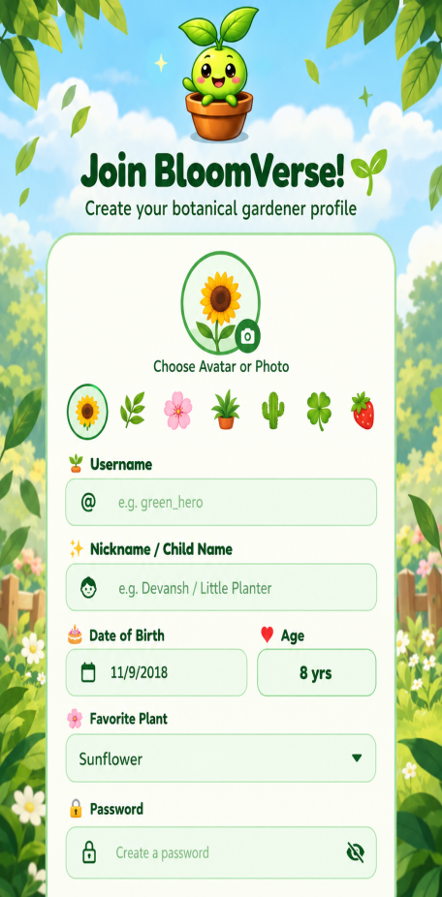
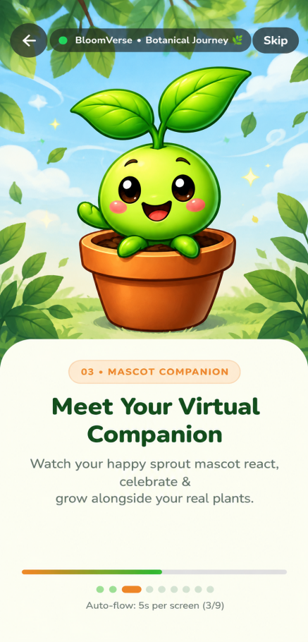
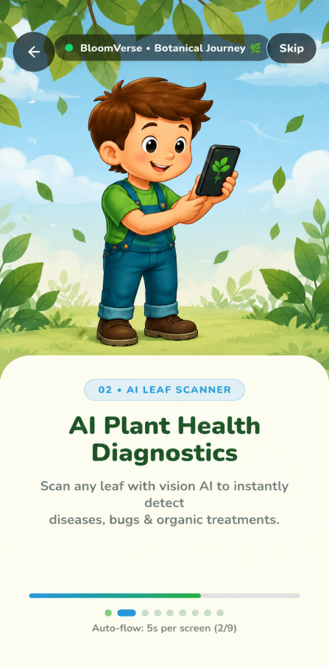
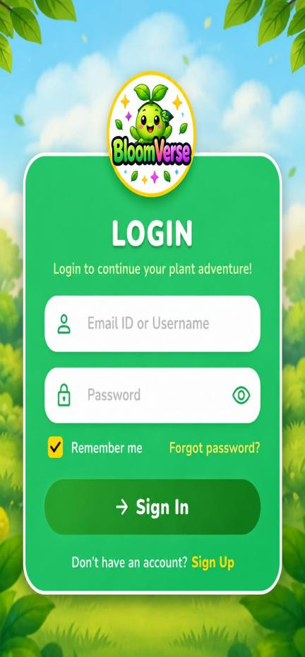
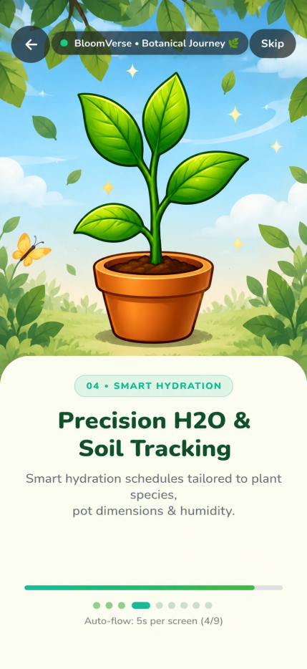
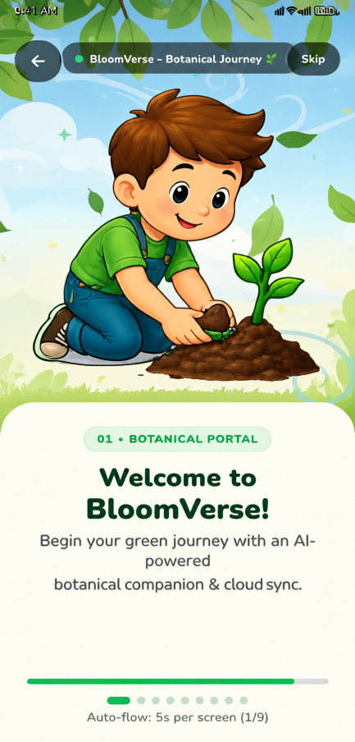
Figure B.1 Login & Registration Page

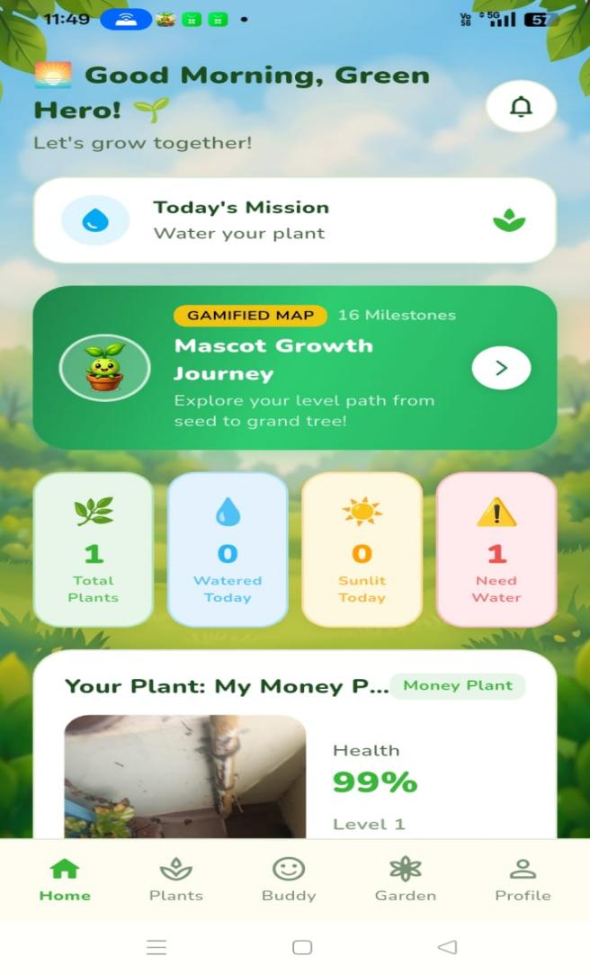

Figure B.2 Home Page
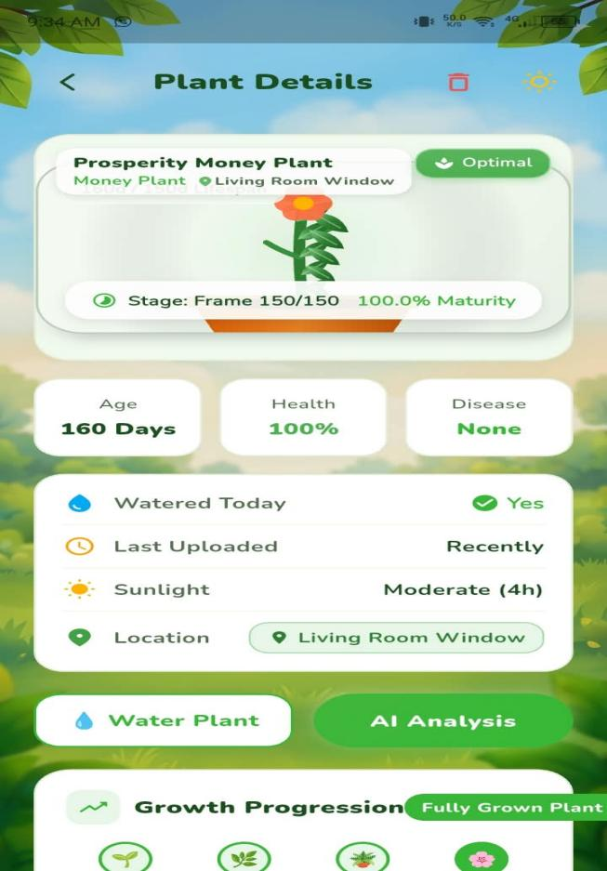

Figure B.3 Virtual Plant Growth Page

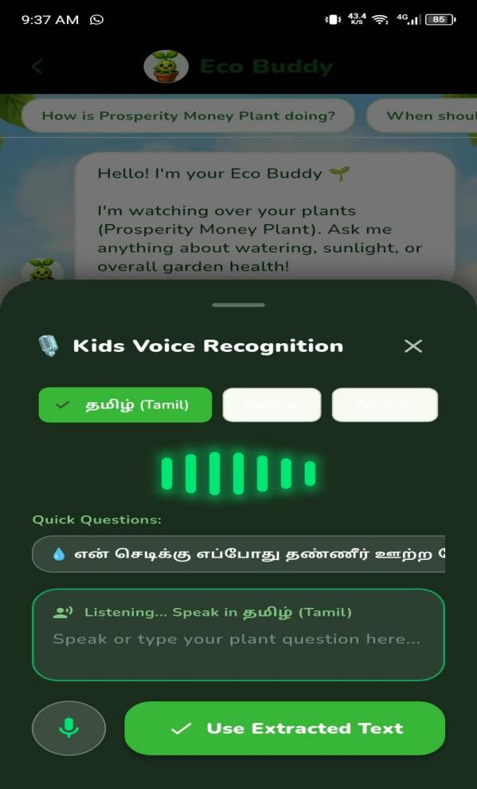
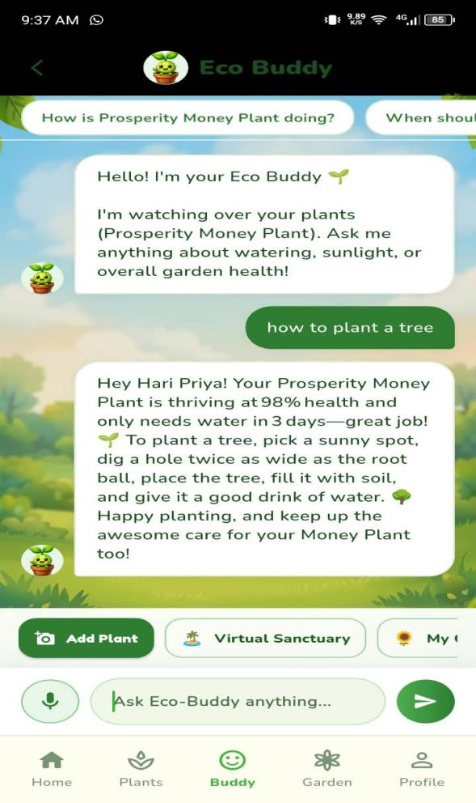

Figure B.4 Eco Buddy Chatbot Page
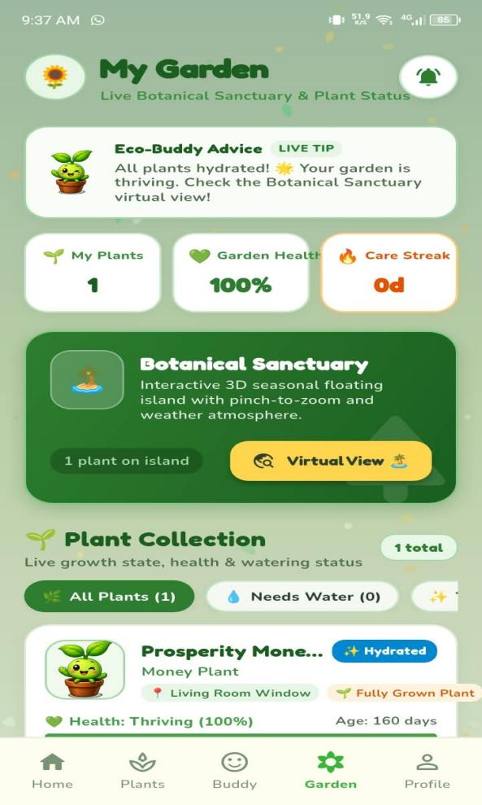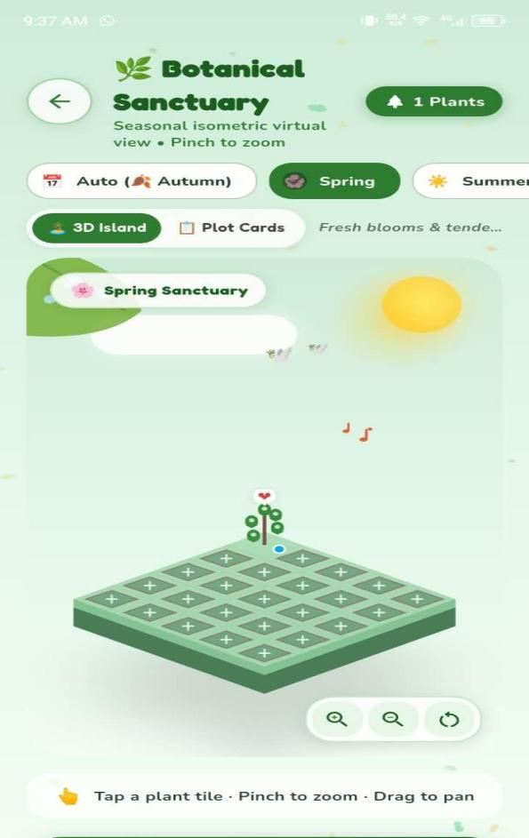
Figure B.5 Garden View Page

REFERENCES

1. Barbedo, J. G. A. (2018). Factors influencing the use of plant disease recognition based on leaf image analysis. Biosystems Engineering.
2. Bishop, C. M. (2006). Pattern Recognition and Machine Learning. Springer.
3. Ferentinos, K. P. (2018). Deep learning models for plant disease detection and diagnosis. Computers and Electronics in Agriculture, 145, 311–318.
4. Flutter. (n.d.). Flutter Framework. Flutter supports cross-platform application development through a shared codebase.
5. Goodfellow, I., Bengio, Y., & Courville, A. (2016). Deep Learning. MIT Press.
6. Google. (n.d.). Gemini AI. Gemini provides multimodal AI capabilities that can interpret image inputs and generate natural-language responses.
7. LeCun, Y., Bengio, Y., & Hinton, G. (2015). Deep learning. Nature, 521, 436.
8. Mohanty, S. P., Hughes, D. P., & Salathé, M. (2016). Using deep learning for image-based plant disease detection. Frontiers in Plant Science, 7, 1419.
9. Oppenheim, A. V., & Schafer, R (2009). Discrete-Time Signal Processing.
10. Rawat, W., & Wang, Z. (2017). Deep convolutional neural networks for image classification: A comprehensive review. Neural Computation, 29(9), 2352–2449.
11. Russell, S., & Norvig, P. (2020). Artificial Intelligence: A Modern approach.
12. Torten, C., & Khoshgoftaar, T. M. (2019). A survey on image data augmentation for deep learning. Journal of Big Data, 6, 60. .
13. Szeliski, R. (2010). Computer Vision: Algorithms and Applications. Springer.
14. Swinburne, D. (n.d.). Plant Health and Care Management. This topic relates to monitoring plant conditions and maintaining suitable care.
15. Taiz, L., Zeiger, E., Møller, I. M., & Murphy, A. (2015). Plant Physiology and Development (6th ed.). Sinauer Associates.

